**Access (Easy)**

**Our analysts need help determining some information about one of their logs, can you help them out?**

**What is the version of the web server?**

1. Info an Apache logs: https://www.sumologic.com/blog/apache-access-log/
2. Version # in the middle column of every log entry.

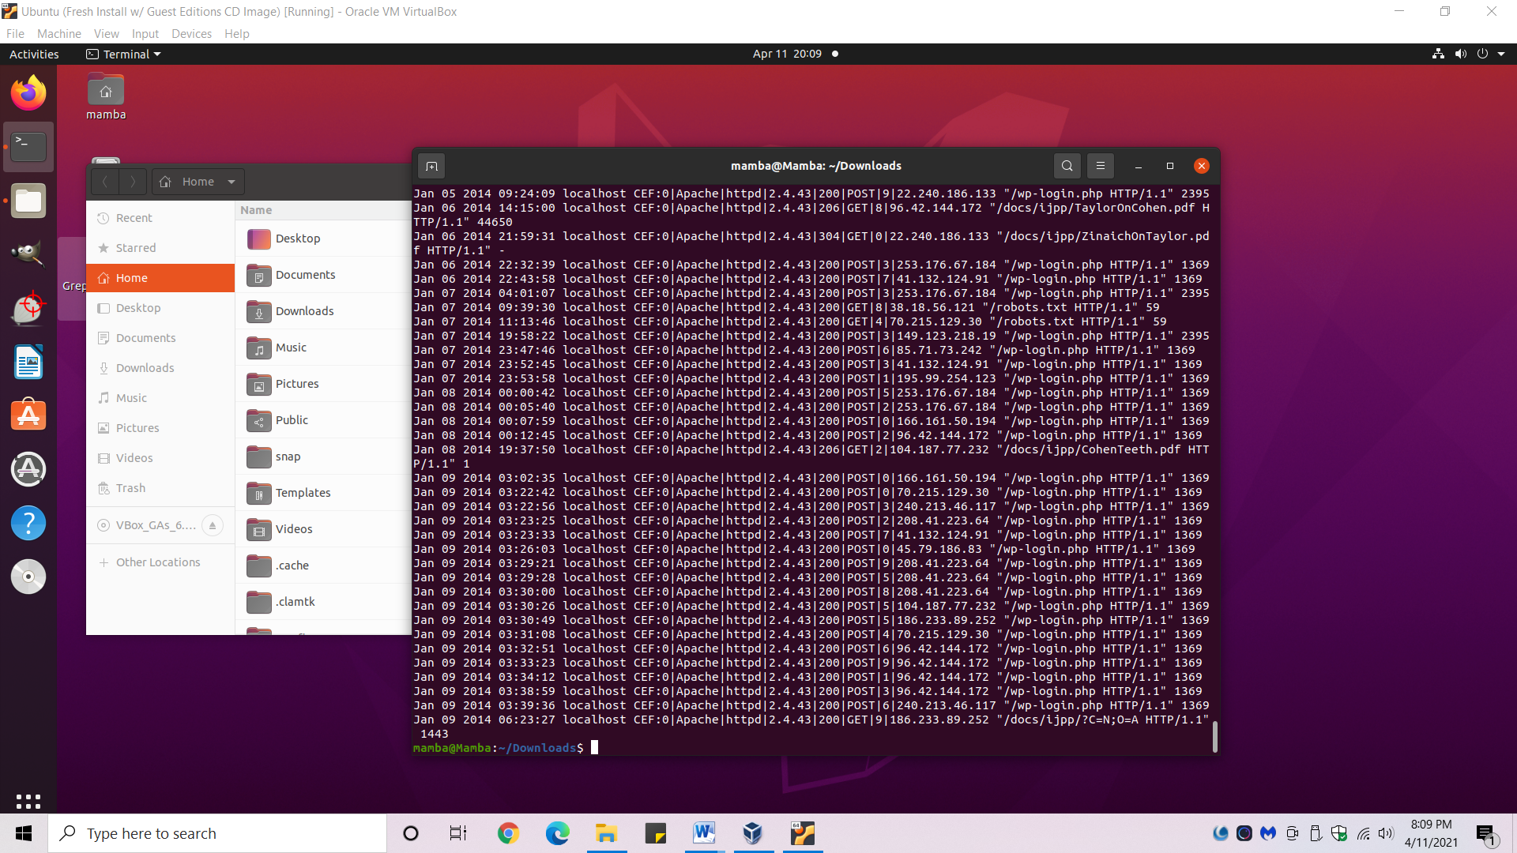

1. Answer: 2.4.43

**How many GET requests were made?**

1. *cd* into the directory where “access.log” is.
2. Type *cat access.log | grep -c 'GET'* into the terminal.
   1. *grep* searches for unique strings.
   2. -c : This prints only a count of the lines that match a pattern.

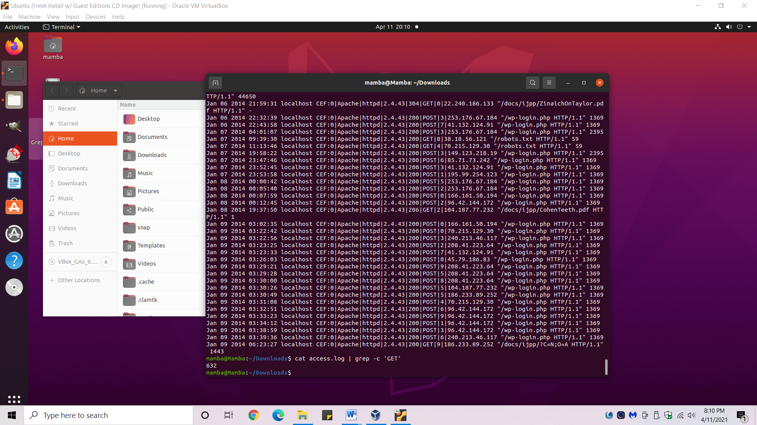

1. Answer: 632

**How many requests were made for "/robots.txt"?**

1. Type *cat access.log | cut -d "|" -f8 | sort | grep -c '/robots'* into the terminal.
2. Answer: 28

**How many requests have a 200 status code?**

1. Type cat access.log | grep -wc '200' into the terminal
   1. -w : Match whole word.
   2. -c : This prints only a count of the lines that match a pattern.
   3. The -w is needed b/c if only the -c is used, a number such as 2000 would make the count go up.
2. Answer: 872

**How many requests have a 404 status code?**

1. Type *cat access.log | grep -c '404'* into the terminal.
2. Answer: 24

**Which IP made the most requests?**

1. Type *cat access.log | cut -d "|" -f8 | sort* into the terminal.
2. Eyeball which one appears the most.
3. Answer: 45.79.186.83

**How many total bytes were transferred?**

1. Type *cat access.log | cut -d " " -f9 | sort* into the terminal.
   1. *sort* is necessary to sort out any non-numbers that may be included.
2. Copy all of the outputted numbers.
3. Add them up with an online calculator.
   1. <https://calculla.com/columnar_addition_calculator>
4. Answer: 107349454